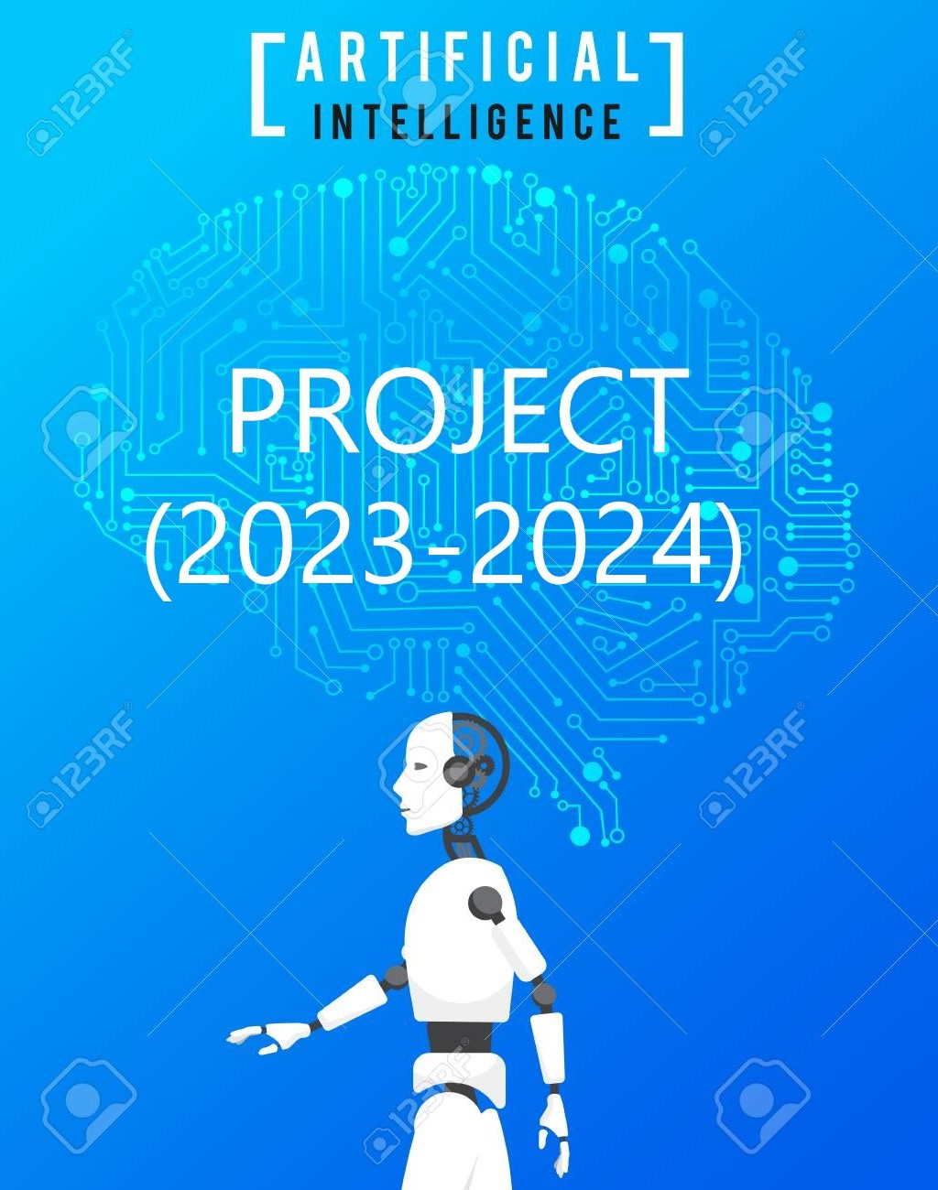

**A.I PROJECT (2023-2024)**

INTRODUCTION:

Artificial intelligence is the simulation of human intelligence processes by machines, especially computer systems. Specific applications of AI include [expert systems](https://www.techtarget.com/searchenterpriseai/definition/expert-system), [natural language processing](https://www.techtarget.com/searchenterpriseai/definition/natural-language-processing-NLP), speech recognition and [machine vision](https://www.techtarget.com/searchenterpriseai/definition/machine-vision-computer-vision).

DETAILS ABOUT PROJECT:

PROJECT NAME : C4 MAIN (chandrayaan 4 model)

PROTOTYPE NAME : C4 PROTO

SCHOOL : ST.JOHN’S SENIOR SECONDARY SCHOOL

TEACHER : MANOJ KUMAR SIR

TEAM NAME : HEXA

TEAM MEMBERS:

* MUKESHWAR RAUDRA
* PRITHIVI RAJ
* SURENDAR
* VARUN KARTHIKEYAN
* SRIHARI
* EZHIL

TOTAL NUMBER OF MEMBERS : 6

C4 MAIN :

C4 MAIN the A.I project was actually inspired by the program of chandrayaan 3 .Chandrayaan-3 is the third mission in the Chandrayaan programme, a series of lunar-exploration missions developed by the Indian Space Research Organisation. Launched in July 2023, the mission consists of a lunar lander named Vikram and a lunar rover named Pragyan, similar to those launched with Chandrayaan-2 in 2019

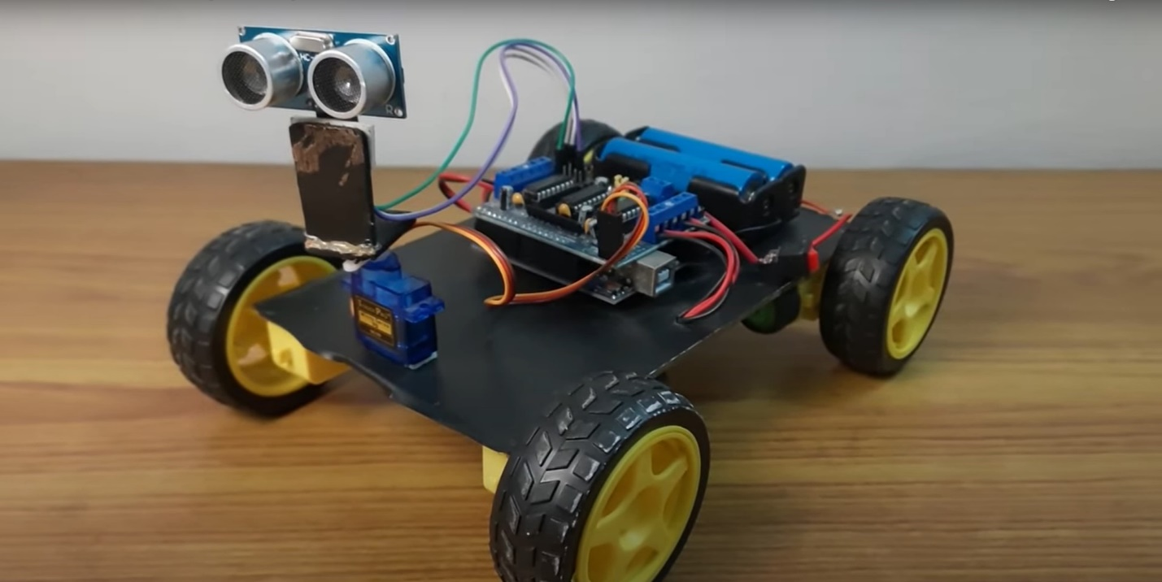 C4 MAIN

FUNCTIONS :

C4 MAIN can be used to detect the objects in the surroundings and also it

scans the object and gathers the data about object then it processed by the inbuilt A.I

thendisplay some information and data about the object in the computer . it also performs

fuctions like obstacle avoiding , object detection C4 MAIN can be control by Bluetooth in

mobile and also performs the Command that we use to give like (move forward , move

backward , move Left, move right ) . if the C4 MAIN get stuck in a place it

automatically Moves to the place where it can move by using its [ ultra sonic sensors ] and

other components that was used . this C4 MAIN basic project can be used in the space

missions to moon and also this concept of A.I can be used in Automobile industries like

(auto driving mode in vehicles) these are the some basic functions of C4 MAIN.

COMPONENTS :

* Arduino UNO
* Motor shield L293D
* DC motors
* Servo motor
* Wheels
* Battery
* Battery adapter
* Jumper wires
* Chassis body (plastic)
* Motor clamp (plastic)
* M3 / 3mm nuts
* Slotted minus M3 (screws)
* Screw driver
* Soldering
* Glue gun
* Switch
* ESP32 (cam)
* Bluetooth module
* USB A-B cable

SOFWARE:



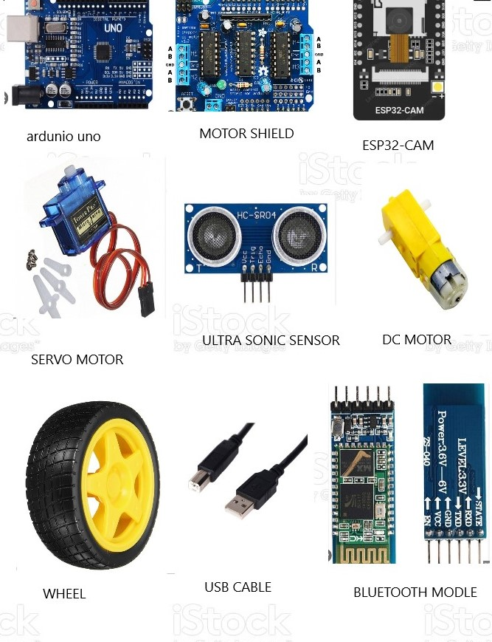MAIN COMPONENTS :

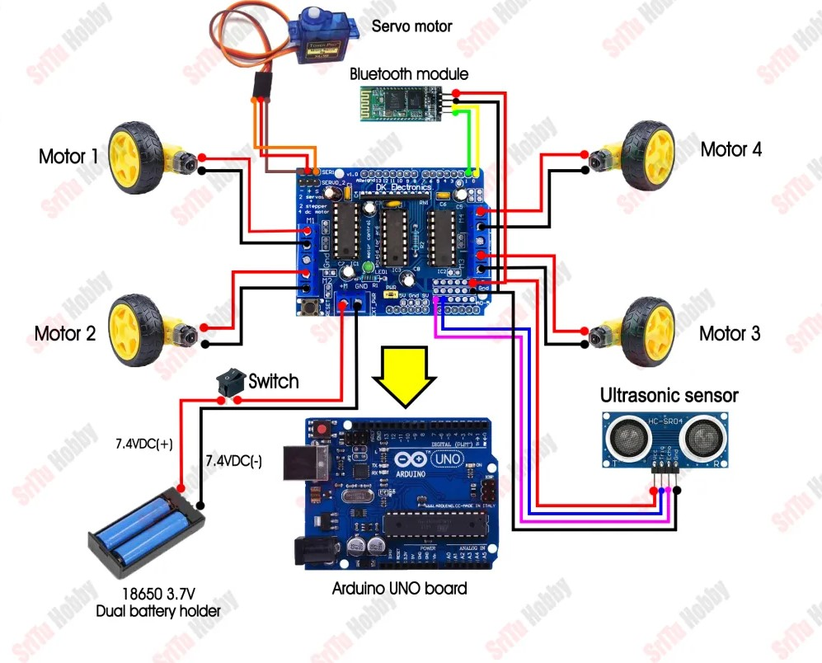CIRCUIT DIAGRAM :

C4 PROTO :

C4 PROTO was the prototype model for the C4 MAIN it was consider

as a stand model to build the main project . it also helps us to recognize how the

final C4 MAIN going to function and how the design is going to be . where the parts

components of the C4 MAIN should be located and we can come to know whether

this part is suitable at this place , whether It will function properly these things we

come to know with the help of C4 PROTO.

COMPONENTS :

* + CARD BOARD
  + GLUE GUN
  + SCISSOR
  + CHART
  + COLOUR PENCIL
  + CRAYONS
  + WHEELS
  + SKETECH
  + TAPE

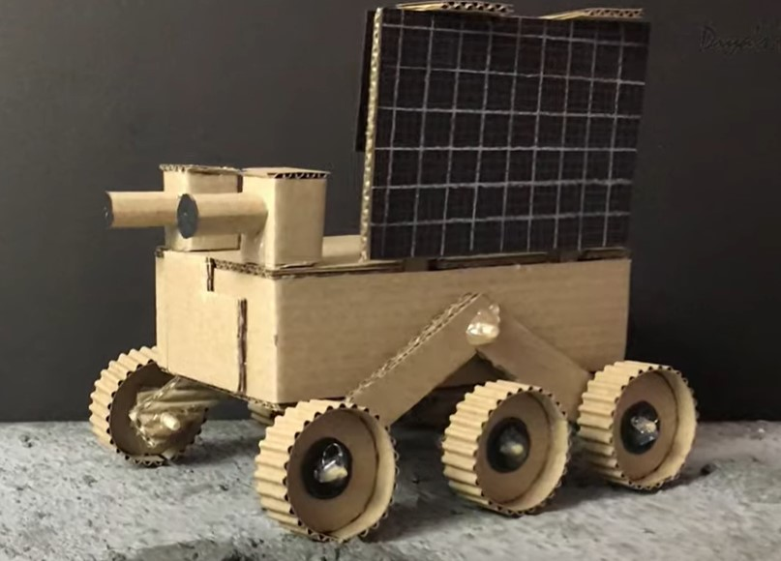C4 PROTO :

DATE OF SUBMISSION OF PAPER WORK :

04/09/23 ( 4TH SEPTEMBER 2023)

DATE OF SUBMISSION OF C4 PROTO :

WITHIN SEPTEMBER END

DATE OF SUBMISSION OF C4 MAIN :

WITHIN NOVEMBER END

PAPER WORK DONE BY :

* MUKESHWAR RAUDRA
* SURENDAR

SOURCE GIVEN BY :

* PRITHIVI RAJ
* VARUN KARTHIKEYAN

C4 PROTO DONE BY :

* PRITHIVI RAJ
* EZHIL
* VARUN KARTHIKEYAN
* SRIHARI

C4 MAIN DONE BY :

* MUKESHWAR RAUDRA
* SURENDAR
* PRITHIVI RAJ
* VARUN KARTHIKEYAN
* EZHIL
* SRIHARI

THIS C4 MAIN/PROTO DONE BY TEAM HEXA

